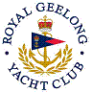 | Royal Geelong Yacht Club Inc.  Est 1859
Trophy Deed of Gift.

Trophy: | W. Thacker Perpetual Shield
Presented by:
Date: | TBA
For: | The Best Club Member
Remarks / Revisions | Originally for the House Committee Aggregate
Click HERE for recipients

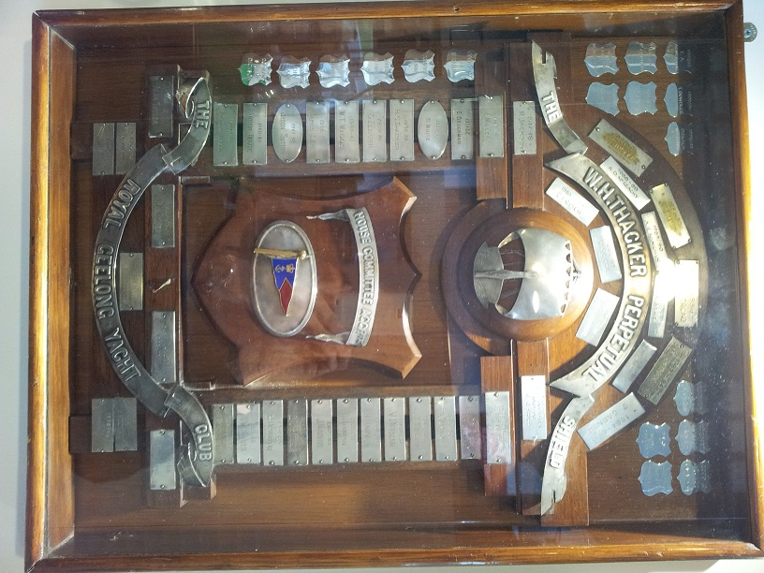
This Shield was hand crafted by Mr C. H. (Chick) Fleet (Snr), a pre-WW2 Club Secretary who trained as a gold smith and later became a jeweller.

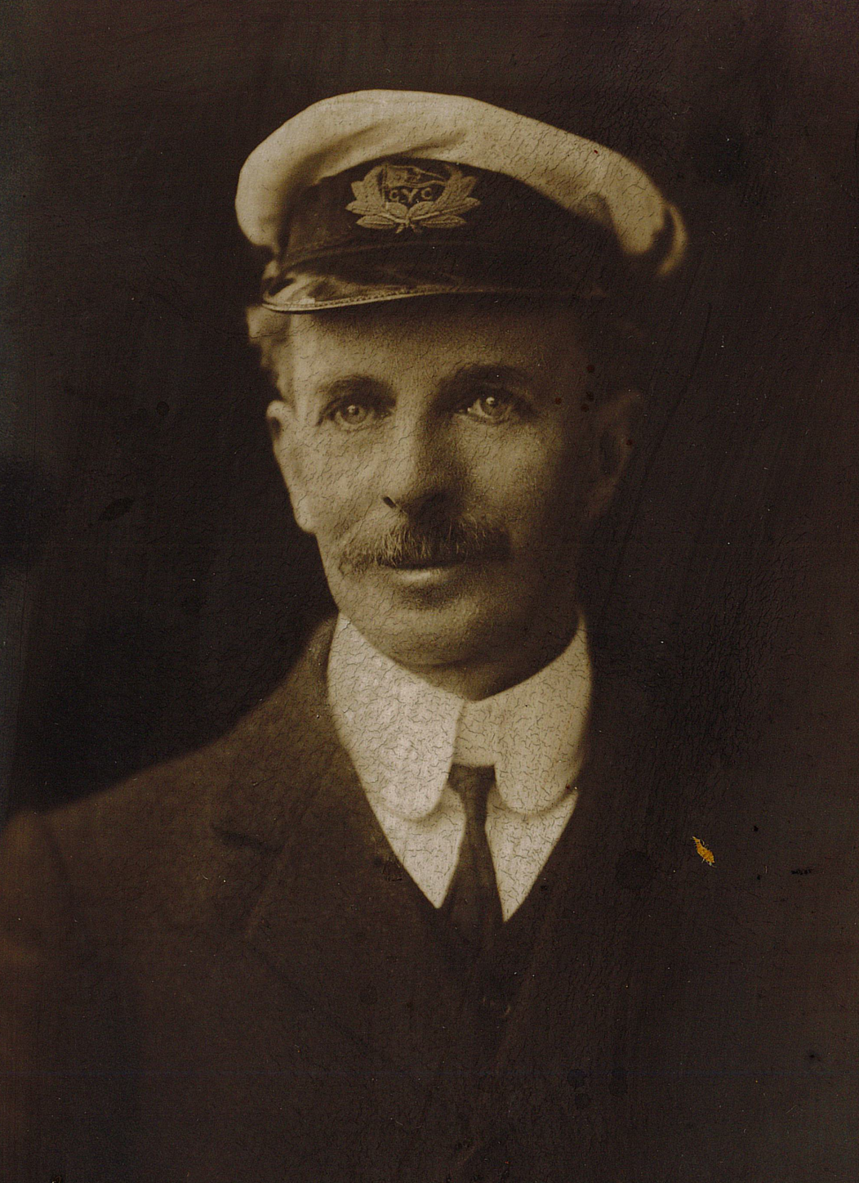

Mr W. H. Thacker

